**HILLMOND SCHOOL**

WEEKLY

**NEWSLETTER**

***April 8th, 2024***

**FIE**

Isue



*“Honouring*

*CREED*

*and School”*



K – 12 Frozen Jr. Tickets REFUNDED

**April Hot Lunch purchasing CLOSED**

Subway Thursday April 18th  
KFC Tuesday April 30th

**NO Extra Curricular   
Activities until further notice**











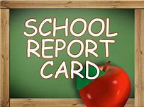

For Grades 10-12

will go out April 19th



**Classes scheduled to begin April 22.**

**Eligible students must present their SGI**

**customer number to the instructor on the first day.**



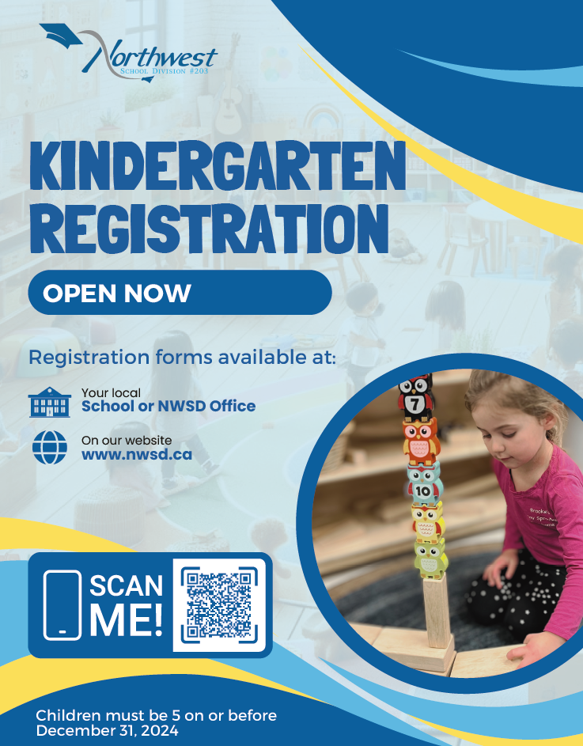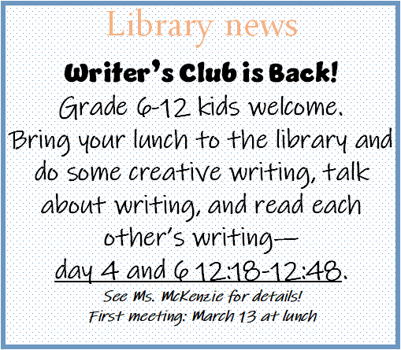



**Happenings Around the Hamlet**



See you at the rink!



